Week 6 lab task named as assignment 1:-

Your task is to compile the provided calculator program, run it, and demonstrate that it performs all the calculator functions (addition, subtraction, multiplication, and division).

Addition:

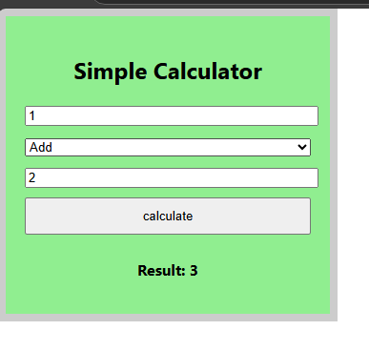

Subtraction:-

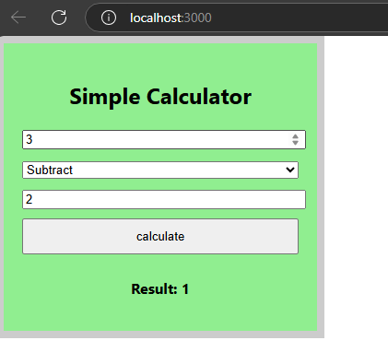

Multiplication:-

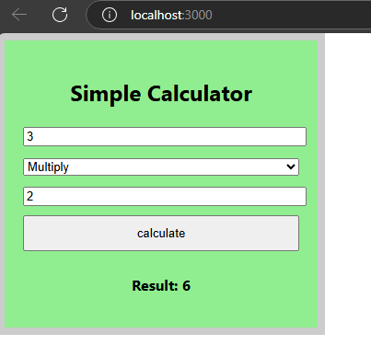

Division:-

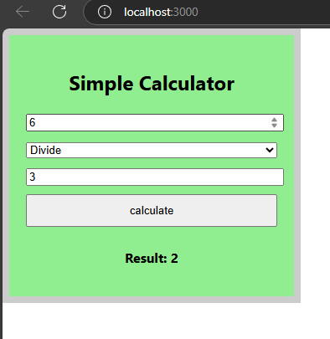

Invalid:-

Short Description of code:

The calculate function performs the actual calculation when clicking the "Calculate" button. Here’s a breakdown:

• document.getElementById is used to get the values of the two input fields and the operator dropdown.

* num1 and num2 are converted to numbers using parseFloat to ensure they’re treated as numbers rather than strings.
* operator is retrieved directly as it’s a string (+, -, \*, /).

• Initialize Result: We initialize the variable result to zero, which will store the result of our calculation based on the selected operator.

The switch statement handles the arithmetic operations based on the selected operator:

• Addition (+): result is set to num1 + num2.

• Subtraction (-): result is set to num1 - num2.

• Multiplication (\*): result is set to num1 \* num2.

• Division (/): If num2 is zero, the result is set to a custom message ("Cannot divide by zero") to prevent a divide-by-zero error.

• Default Case: If an invalid operator is selected, the result is "Invalid Operation."

The button triggers the calculate function onclick.

• onClick={calculate}: Sets up an event handler so that clicking the button calls the calculate function.

At last, I have imported Calculator function from SimpleCalculator to index.js file using: < Calculator/> under the React.Render in index.js to run the simple calculator which perform different kinds of operation.